### UE20CS301

## Database Management System

## Lab 10 – Connecting Python Application to MySQL Database

Name : Renita Kurian

SRN : PES1UG20CS331

Roll No. : 13

1. Train Table

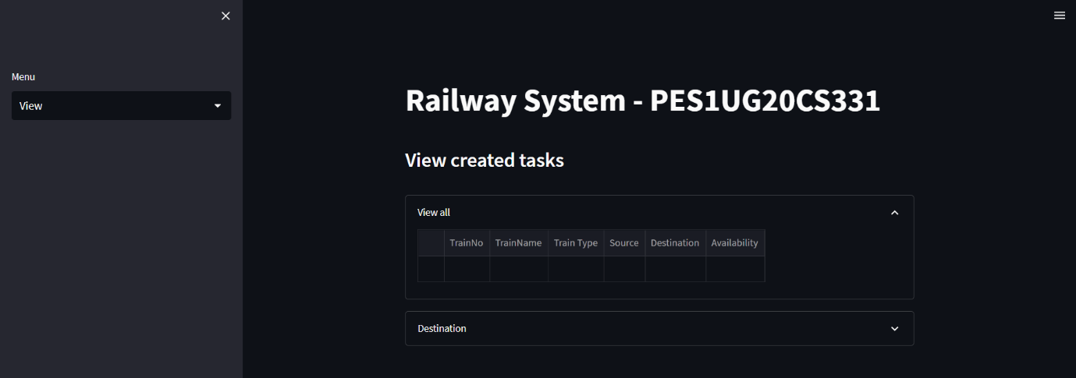

2. UI

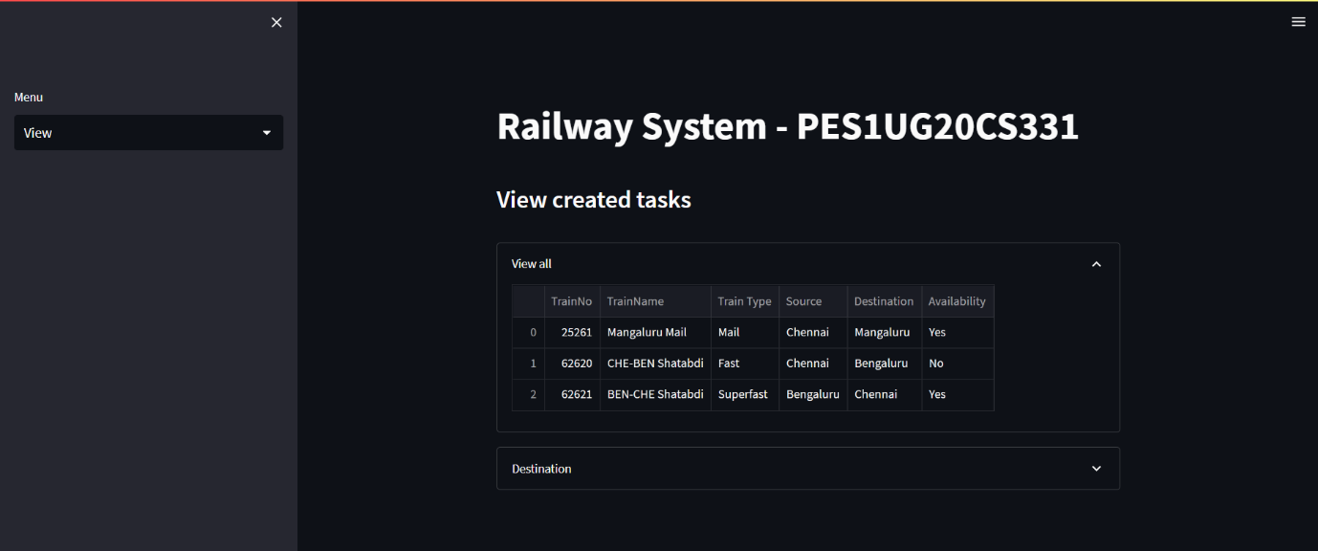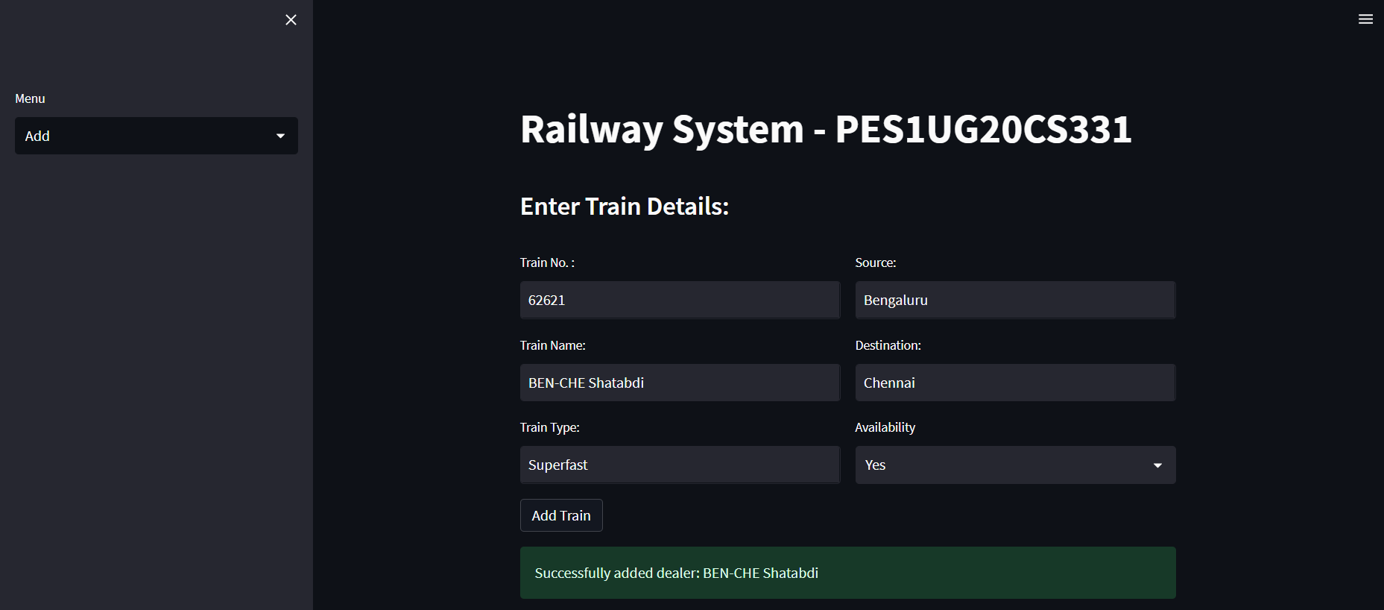

3. Train Table Populated

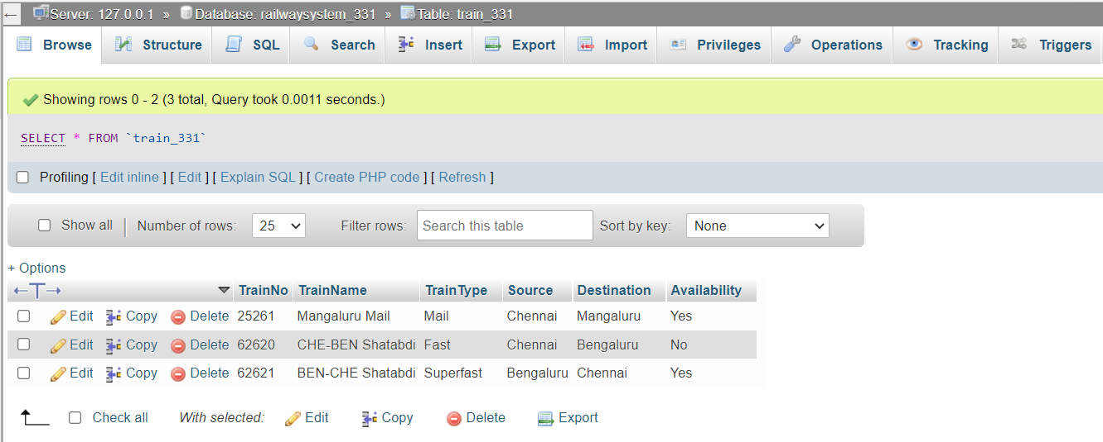

4. View in UI



5. Update train data

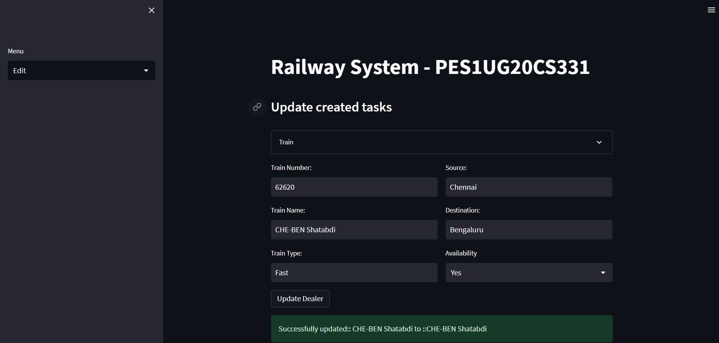

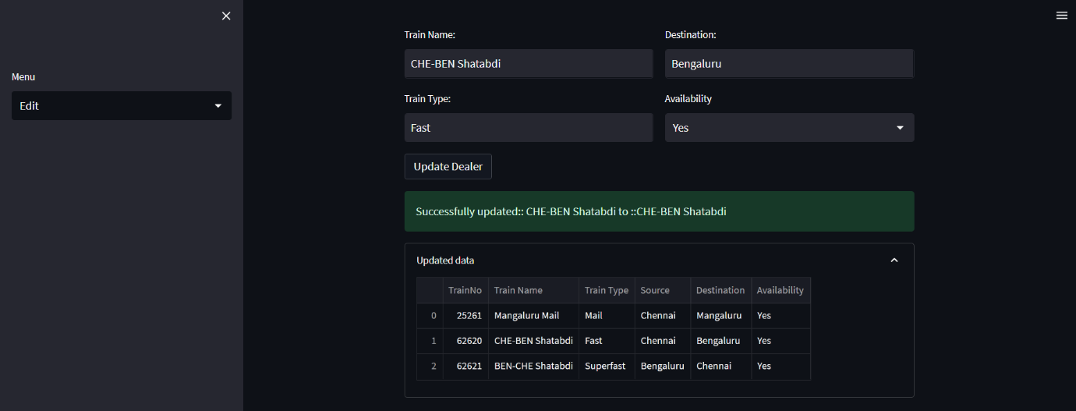

6. Delete train data

